Our library management system has been developed with the main objective of making knowledge more accessible to all users. I am delighted to report that our library management website project has been successful in achieving various key objectives. Let's take a closer look at the specifics:

* Separate login pages are available for the Admin and User.
* For the Admin:

1. The Admin can add new books to the website.
2. They can upload e-copies of every book available in the library.
3. They have the option to accept book requests made by the user.
4. They can view the list of all users.
5. The Admin can issue a book to a user directly when they visit the library.
6. There is an option for collecting books.
7. The Admin can also view suggestions provided by users to improve website and library facilities.

* For the User:

1. The User can view all available books in the library.
2. They can reserve books in advance online to save time instead of going to the library.
3. Users can view the books they have borrowed so far.
4. They can also view the books they have previously viewed.
5. There is an option for providing feedback, which allows users to give their opinions on the quality of the services offered by the website.

**Functionality:**

**Home Page:**

In the LMS homepage, a navigation bar is located on the left side of the website, providing access to all available page elements.

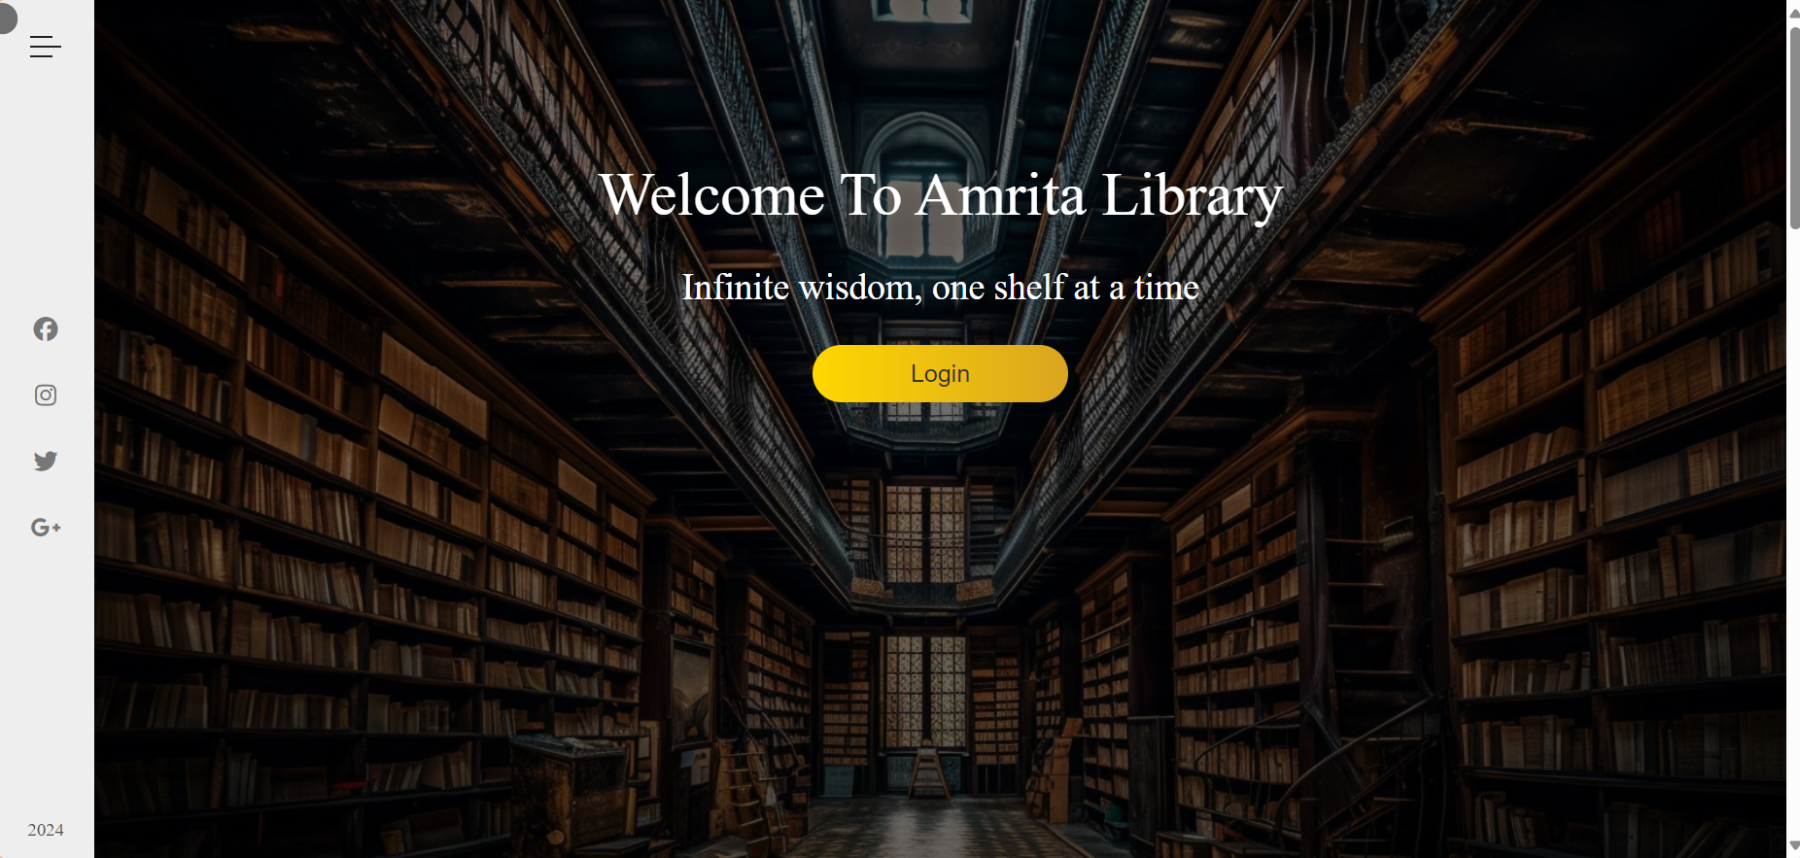

**Nav bar**:  
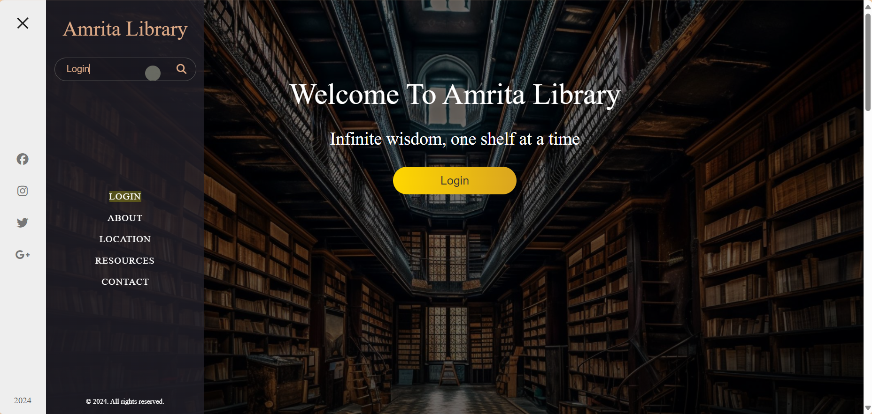

* When we click on an item in the navigation bar, such as "Login", it will be highlighted and we can select it to be redirected to that specific page.
* As for the website's appearance, you can refer to the program's zip folder that we have provided.

**Login Page**

* Here we have 2 types of users, Admin and User.
* By giving respective credentials for Admin or User it will Redirect to that page.
* And for valid credentials we have connected to the database, such that only valid users and admins,whose credentials are stored in the database, are allowed to access.

**Admin Page:**

**Available Books:**

* As an admin, you have the ability to add new books to the system which will then be visible to users in their "available books" section.
* Additionally, you can update the count of available books when a user borrows a book from the library or when you accept a request for a book from a respective user.
* You also have the option to delete any book from the system.
* Lastly, we have categorized the books so that they are easier to find and organize.

**Upload Book:**

* User inputs book name, category, and file version for download.

**Request:**

* Here admin can see all the users who have requested for the respective book
* Also admin have a option of accepting the request or declining it.

**Users list:**

* Here admin can see all the users, who took books from the library, their date of issue, and their date of return of the book, based on that admin can see whether the user is due or not.

**Issue Book:**

* The administrator of the library takes note of the details of all users who come to borrow a book. They record the user's information, such as their name and contact details, along with the date of issue and the expected return date. This information is then added to a list.
* The administrator can access the list of users on the user list page.
* When a user borrows a book, the count of available books decreases by one.

**Collect book:**

* When a user comes to return a book, admin collects tha name of user, book name etc and collects the book.
* When admin collects book, books count increments by 1.

**Suggestions:**

* Admin can see all the suggestions given by the users so that he can improve the facilities to the user.

**User Page:**

**Available Books:**

* Here user can see all books that are available in library.
* If user want to know whether his required book available in library or not, he can see through website instead of coming to library and knowing book is not available.
* Here books are divided into categeories, so that searching for respective book for user becomes easy.

**Reserve Book:**

* If user want to reserve his required book, he can go through this page and reserve book.
* This saves the time of user. It is like the prebooking a book.

**View your book:**

* Here user can see the books he took from library, which are in due.
* Like date of issue and when he need to return.

**Download Book:**

* Here user can see the ecopy of all books available In library, so that he can download and read when ever he need.

**Feed Back:**

* Here we have feedback form, so user can fill the form by that admin can understand how the library or website services are.
* It will help admin to take necessary actions to improve.

**History:**

* Here user can see all the reserved books that are accepted by the admin.
* This will help user to know what books he had taken into his list.